Características dos projetos com suas referências

Estrutura

Estrutura 2 eixos (bi-dimensional)

Essa estrutura é boa com relação à simplicidade matemática para os controladores, sendo um problema com estabilização de 2 ângulos apenas (pitch and roll), pode ter um pilar central para estabilizar (porém sofre com vibrações pois não amortece a plataforma), ou pode ter 4 braços sem pilar central (visando amortecer a plataforma)

- Ball On The Plate Model Based on PID Tuning Methods
- Stability Control Investigation of a Self-Balancing Platform on the Robot Smart Car Using Navigation Parameters
- Model-Based Control of a Large-Scale Ball-on-Plate System With Experimental Validation
- Real-time control of ball balancer using neural integrated fuzzy controller
- Reinforcement Learning and Fuzzy PID Control for Ball-on-plate
- Design, Control and Implementation of a BaIlon Plate Balancing System
- AU Ball on Plate Balancing Robot*

modelo extra:
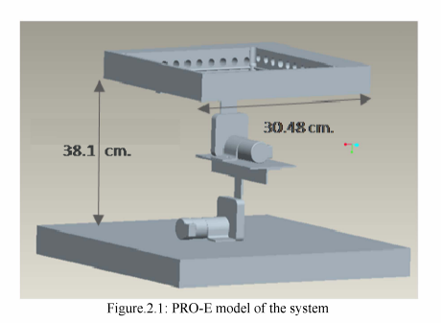

Estrutura em Delta

Estrutura que possibilita carregar mais carga em peso e pode se ajustar com problemas de amortecimento devido à não usar um pilar central, todavia o modelo matemático para o controle de estabilização da plataforma se apresenta um pouco mais complexo devido a aumentar 1 grau de liberdade na modelagem do robô

- Control of Balancing Mobile Robot on a Ball with Fuzzy Self-adjusting PID

modelo extra (esférico)

- Designing and controlling a self-balancing platform mechanism based on 3-RCC spherical parallel manipulator

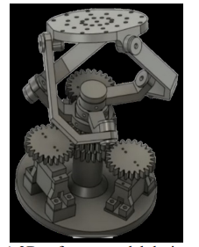

Estrutura Stuart (Delta com 6 atuadores)

Estrutura mais complexa entre as 3, utilizando 6 atuadores para estabilizar a plataforma, com seus 6 graus de liberdade, esse robô consegue aguentar elevadas cargas e ter uma estabilização mais firme.

- Adaptive 6 DOF Self-Balancing Platform for Autonomous Vehicles (atuador prismático)
- Ball Balancing on a Stewart Platform using Fuzzy Supervisory PID Visual Servo Control

Sensores

Encoder para motores DC de controle de estabilização
- LMI Based Robust H2 Control of a Ball Balancing Robot with Omni-wheels
- Hybrid Adaptive Precise Position Control of Three Degrees Freedom Platform
- Model-Based Control of a Large-Scale Ball-on-Plate System With Experimental Validation

IMU sensor (é utilizado apenas 1 IMU)
- LMI Based Robust H2 Control of a Ball Balancing Robot with Omni-wheels
- Pose Optimization of a Single Ball Self-balancing Mobile Robot Based on IMU and Visual Fusion
- Control of Balancing Mobile Robot on a Ball with Fuzzy Self-adjusting PID
- Stability Control Investigation of a Self-Balancing Platform on the Robot Smart Car Using Navigation Parameters
- Adaptive 6 DOF Self-Balancing Platform for Autonomous Vehicles (MPU 6050)
- Designing and controlling a self-balancing platform mechanism based on 3-RCC spherical parallel manipulator (MPU 6050)

Câmera
- Ball On The Plate Model Based on PID Tuning Methods
- Model-Based Control of a Large-Scale Ball-on-Plate System With Experimental Validation
- Real-time control of ball balancer using neural integrated fuzzy controller
- I-PD Controller Design based on Generalized KYP Lemma for Ball and Plate System
- Reinforcement Learning and Fuzzy PID Control for Ball-on-plate
- Ball Balancing on a Stewart Platform using Fuzzy Supervisory PID Visual Servo Control
- AU Ball on Plate Balancing Robot*

Resistor touch screen
- Ball on the plate balancing control system, Michael Kopichev (locate the position of an object on plate)

Potenciômetro como Sensor de ângulo
- Ball on the plate balancing control system

IR para localização do objeto sobre a plataforma
- Design, Control and Implementation of a BaIlon Plate Balancing System

Motores

DC
- LMI Based Robust H2 Control of a Ball Balancing Robot with Omni-wheels
- Hybrid Adaptive Precise Position Control of Three Degrees Freedom Platform
- Adaptive 6 DOF Self-Balancing Platform for Autonomous Vehicles
- Design, Control and Implementation of a BaIlon Plate Balancing System

Servo
- Ball On The Plate Model Based on PID Tuning Methods
- Stability Control Investigation of a Self-Balancing Platform on the Robot Smart Car Using Navigation Parameters
- Real-time control of ball balancer using neural integrated fuzzy controller (SRV02)
- I-PD Controller Design based on Generalized KYP Lemma for Ball and Plate System (SRV02)
- Ball Balancing on a Stewart Platform using Fuzzy Supervisory PID Visual Servo Control (wCK-1108)
- AU Ball on Plate Balancing Robot*
- Designing and controlling a self-balancing platform mechanism based on 3-RCC spherical parallel manipulator (MG-996R)

Passo
- Ball on the plate balancing control system

modelo de controle de estabilização:
inner loop: ângulo dos motores
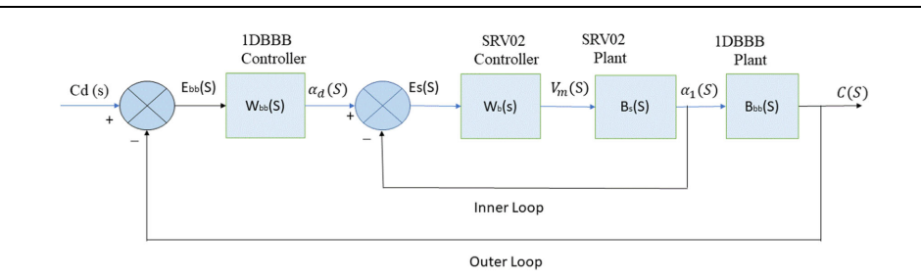
outer loop: inclinação da plataforma (2 DOF ou 1 DOF [beam balance])

